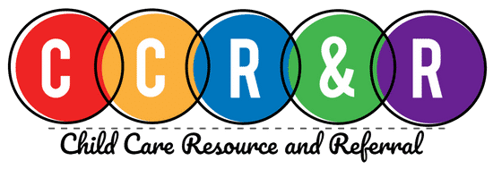
Family Engagement Month 2021
November

Sunday | Monday |  | Tuesday |  | Wednesday | Thursday | Friday | Saturday
 | 1 |  | 2 |  | 3 | 4 | 5 | 6
 | NATIONAL FAMILY LITERACY DAY  Visit your local library or bookstore and read together. |  | Plan a day with no electronics. Read books, play board games or do puzzles with your child. |  | Praise your child for their efforts rather than their abilities. | Use facial expressions and have your child guess the emotion you are showing. Are you happy, sad, or angry? | Have fun with science. During bath time let your child discover which objects will float and which objects sink. | Listen to different types of music and sing different types of songs.
7 | 8 |  | 9 |  | 10 | 11 | 12 | 13
NATIONAL PARENTS AS TEACHERS DAY Parents are their children's first and most important teachers. | Read to your child daily. Research shows that it helps your child become a reader. |  | As a family, learn more about recycling efforts and pledge to reduce reuse and recycle. |  | Veteran’s Day  Talk to your child  about why we honor those who courageously serve our country. | Talk, read and sing to your baby or young child every day. It helps your child’s brain development. | Talk with your family about helping others and why it is important. | Take a walk through your home and help your child find everything that has numbers on it.
14 | 15 |  | 16 |  | 17 | 18 | 19 | 20
Invite your child to help you plan a meal, make a grocery list, shop and help prepare the meal. | AMERICAN EDUCATION WEEK  Thank a teacher or child care provider for the work they do. Talk to your child about the importance of learning. |  | Use “downtime” in the car or on a walk to sing songs or teach nursery rhymes to your child. |  | NATIONAL CAREER DEVELOPMENT DAY  Explore and talk about different jobs or careers  with your child. | NATIONAL PARENT INVOLVEMENT DAY  Take the Pledge and let your child know you’re committed to their success. | Flip through old family photo albums. Tell stories to your child about family members. | Listen! It’s the #1 thing a parent can do to support their child.
21 | 22 |  | 23 |  | 24 | 25 | 26 | 27
Make up a story to tell your child  about a favorite family member or friend. | Encourage conversation among family members at the dinner table. |  | Help your child find numbers, shapes or colors during the day. Focus on one of these and see how many he can find. |  | Connect with Vroom and turn everyday moments into brain building moments. | Thanksgiving Day  Talk about things for which your family is grateful. | Ask your child to stack blocks or sort objects by size. This helps them to become problem solvers. | Play your favorite music and dance with your child.
28 | 29 |  | 30
Read I Wonder with your child and make a list of things that they wonder about |  | Visit a local park or other attraction and talk about what you see. Find out about the Junior Ranger Program. |  | Visit a local museum with your child. Talk about the exhibits. Use pictures of the trip to write a story together.

